**BUILDING A FACE DETECTION AWS APP**

**NAME:** PAVITHRA.B

**e-mail:** [pavithrababu0199@gmail.com](mailto:pavithrababu0199@gmail.com)

**Login to AWS:**

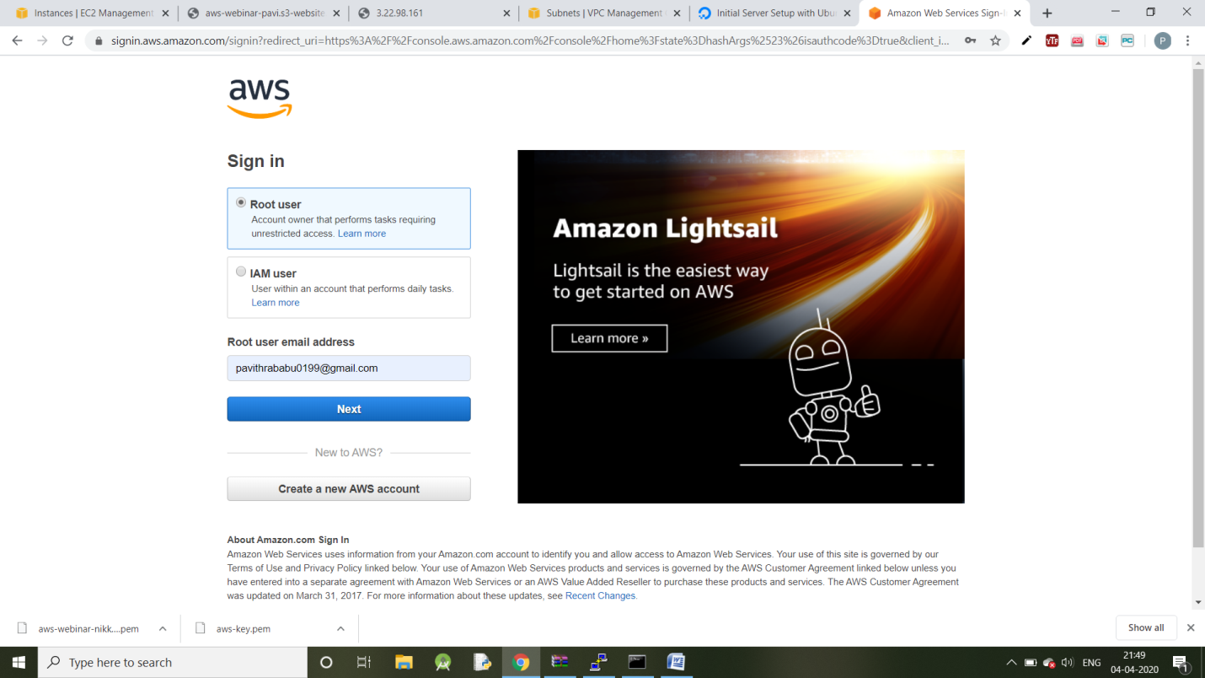

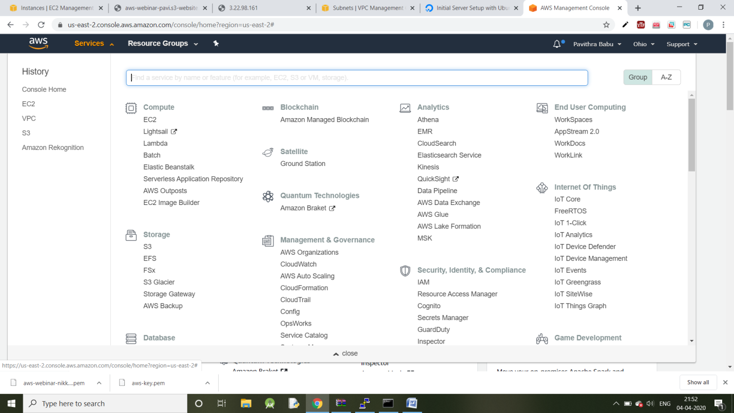

**EC2 Dashboard:**

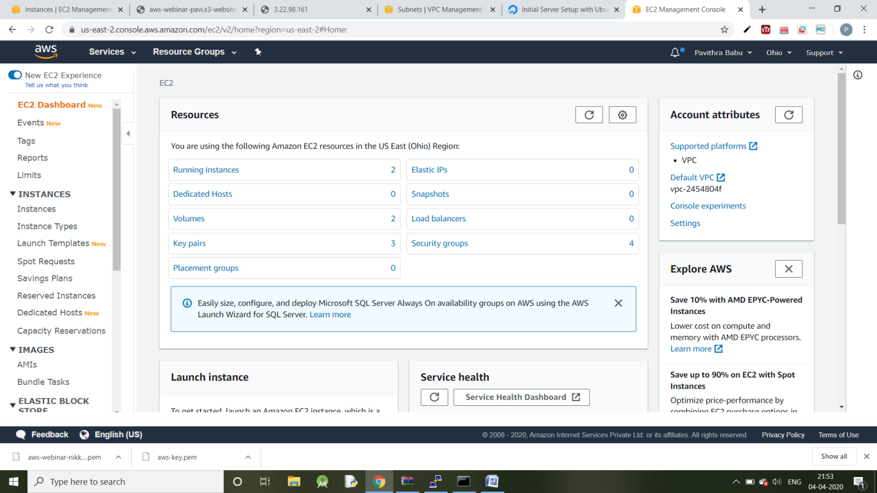

**S3 Dashboard:**

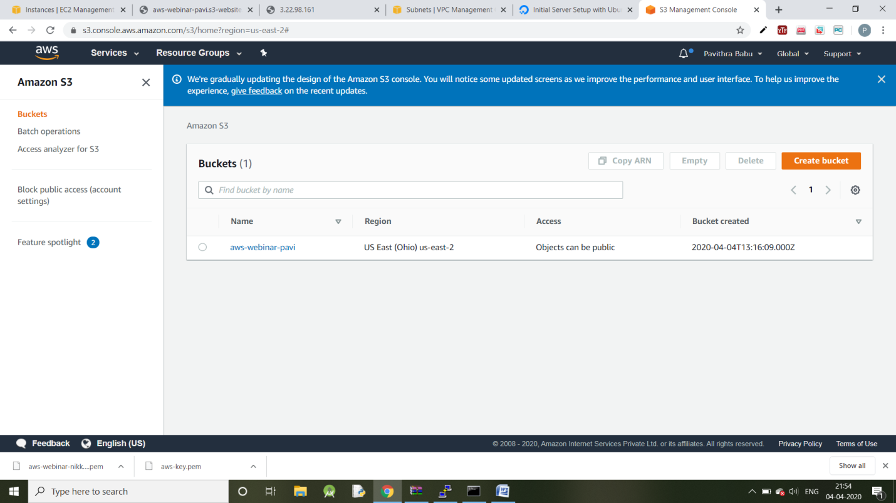

**Amazon Rekognition:**

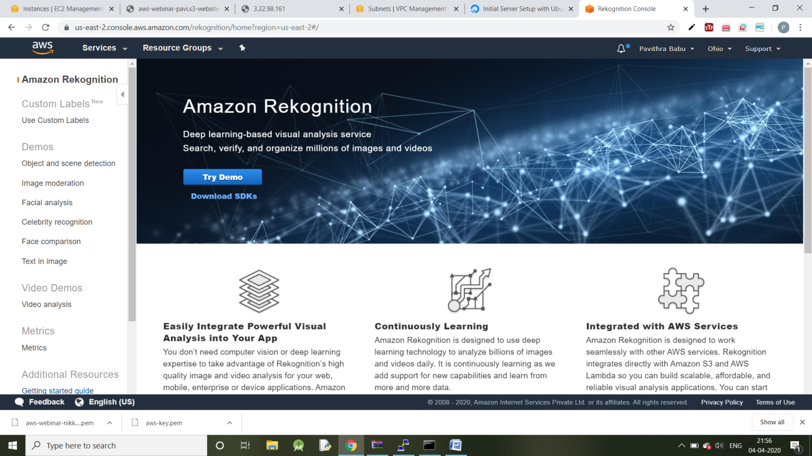

**Creating EC2 Instance:**

**Choosing AMI:**

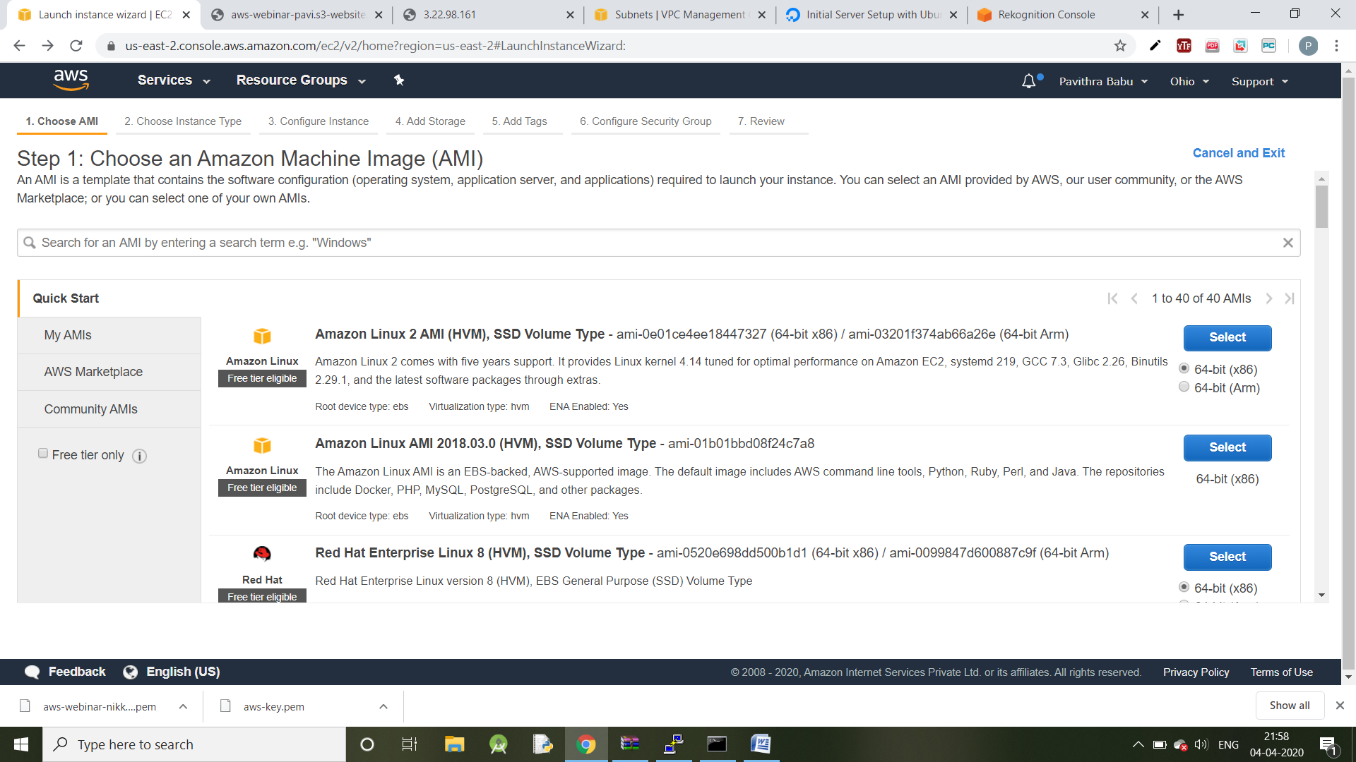

**Choosing an Instance type:**

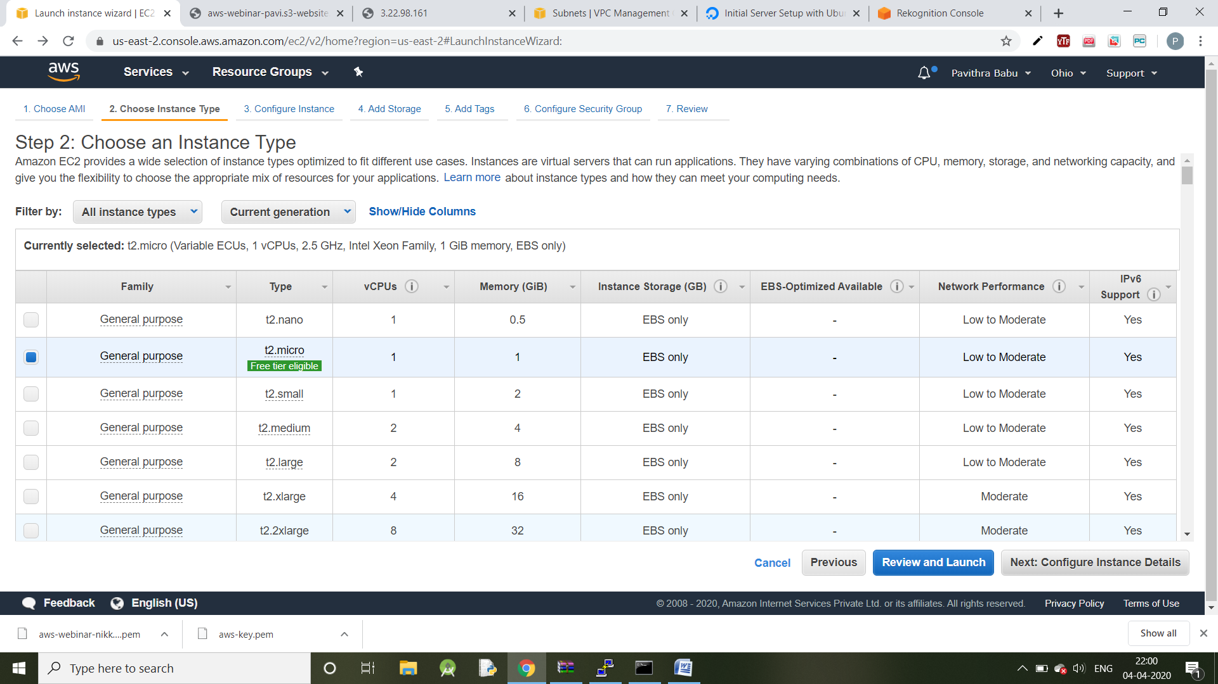

**Adding Storage:**

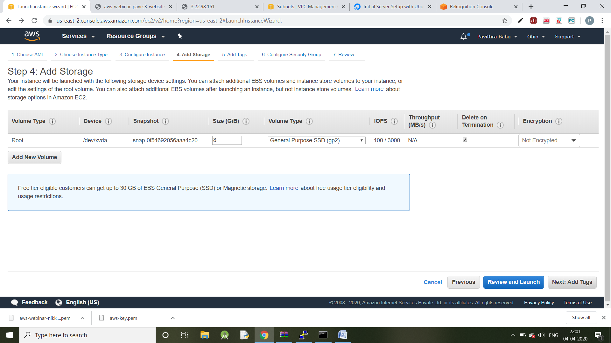

**Configuring Security Group:**

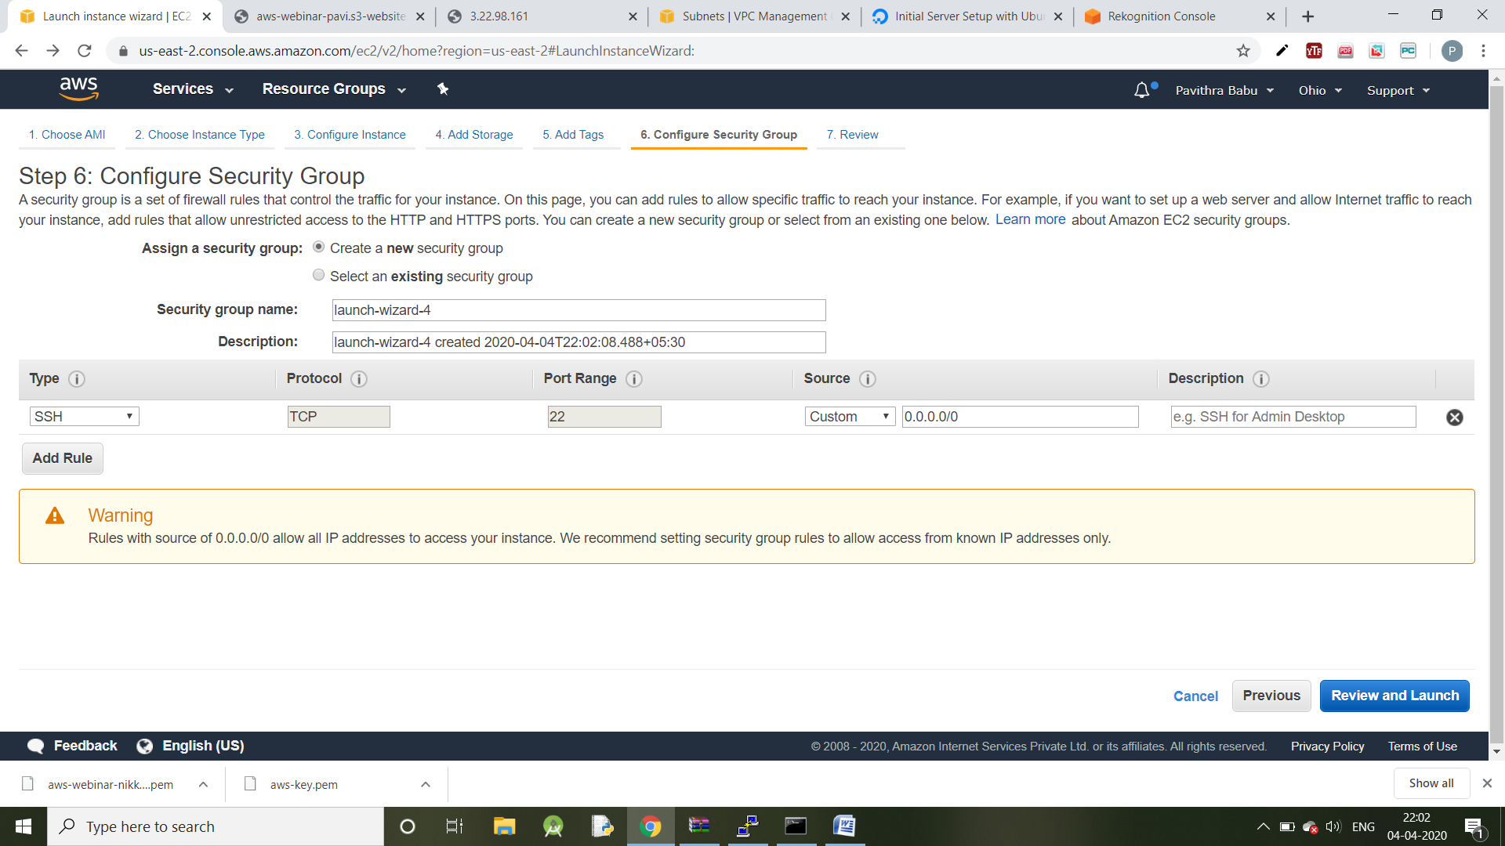

**Launching Instances:**

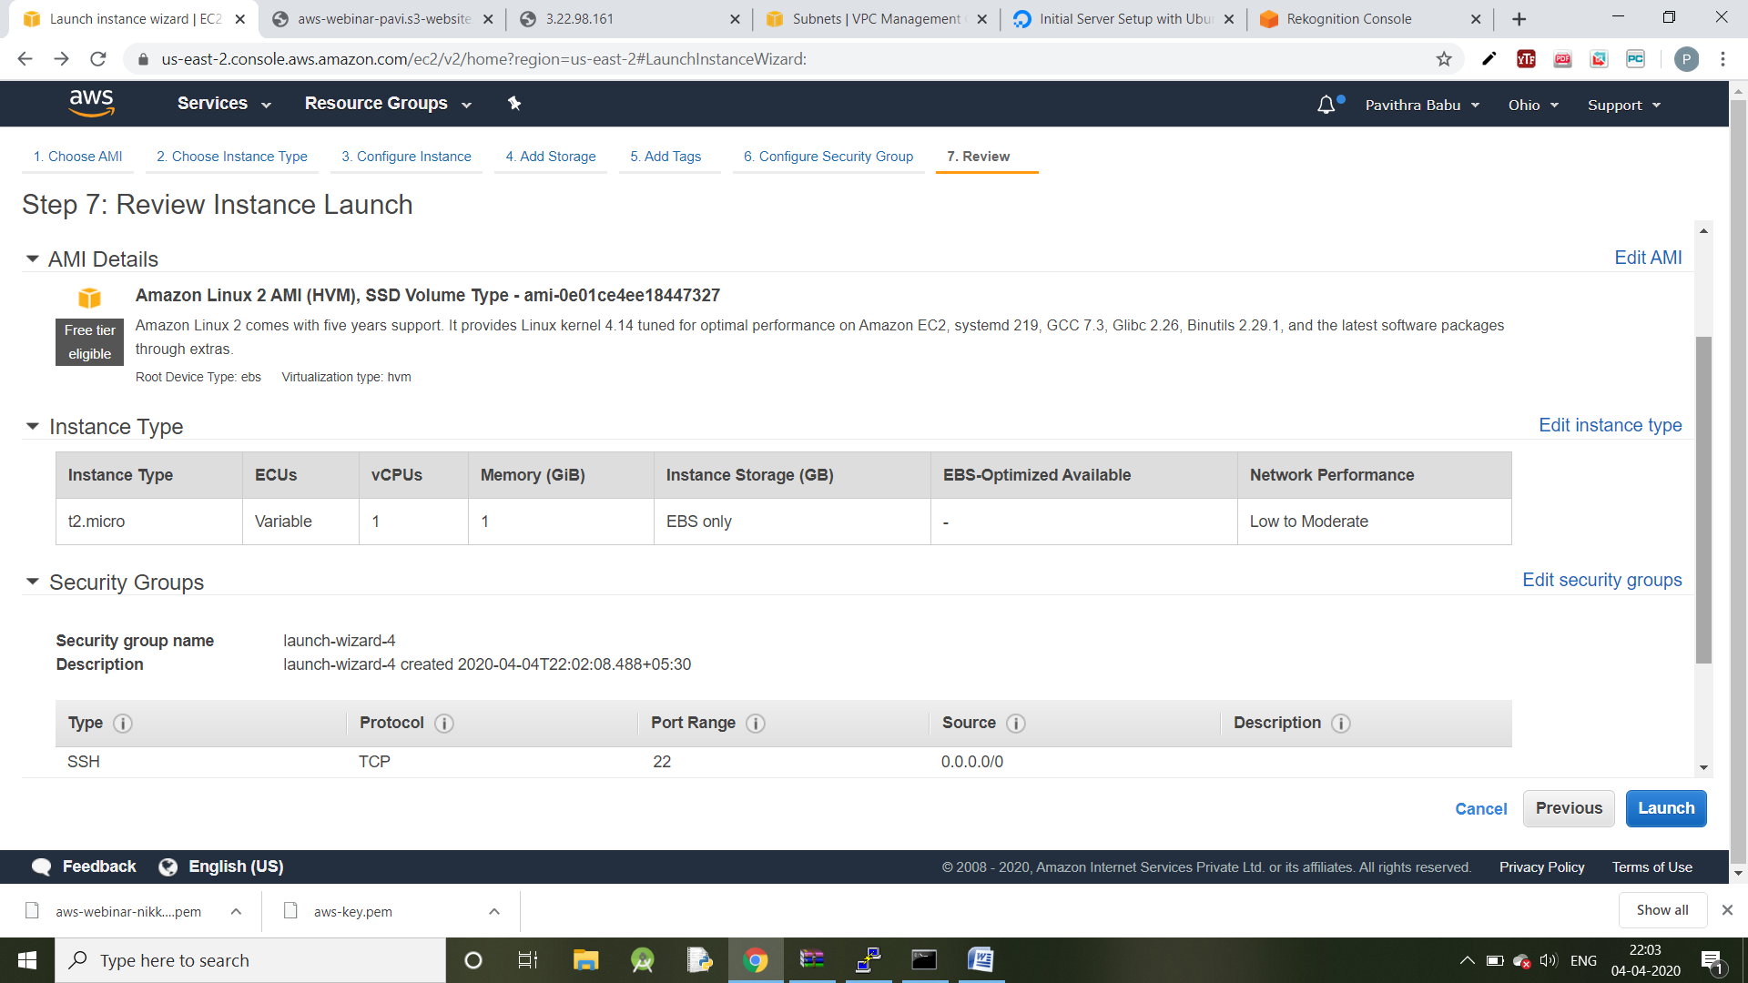

**Downloading Keypair:**

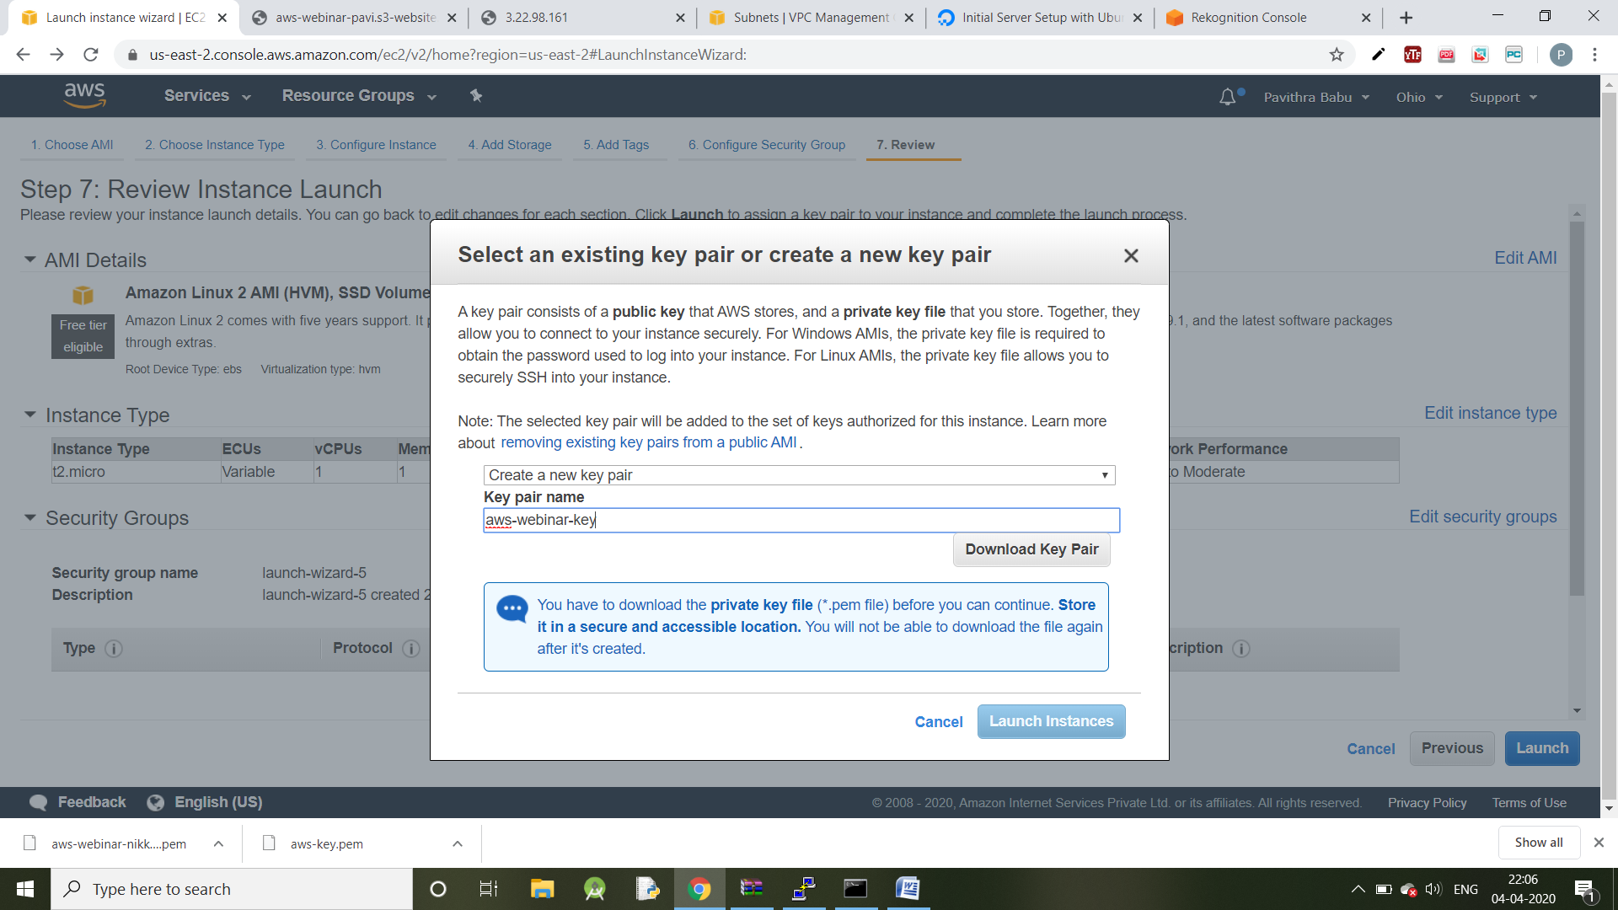

**Converting PEM to PPK using Puttygen:**

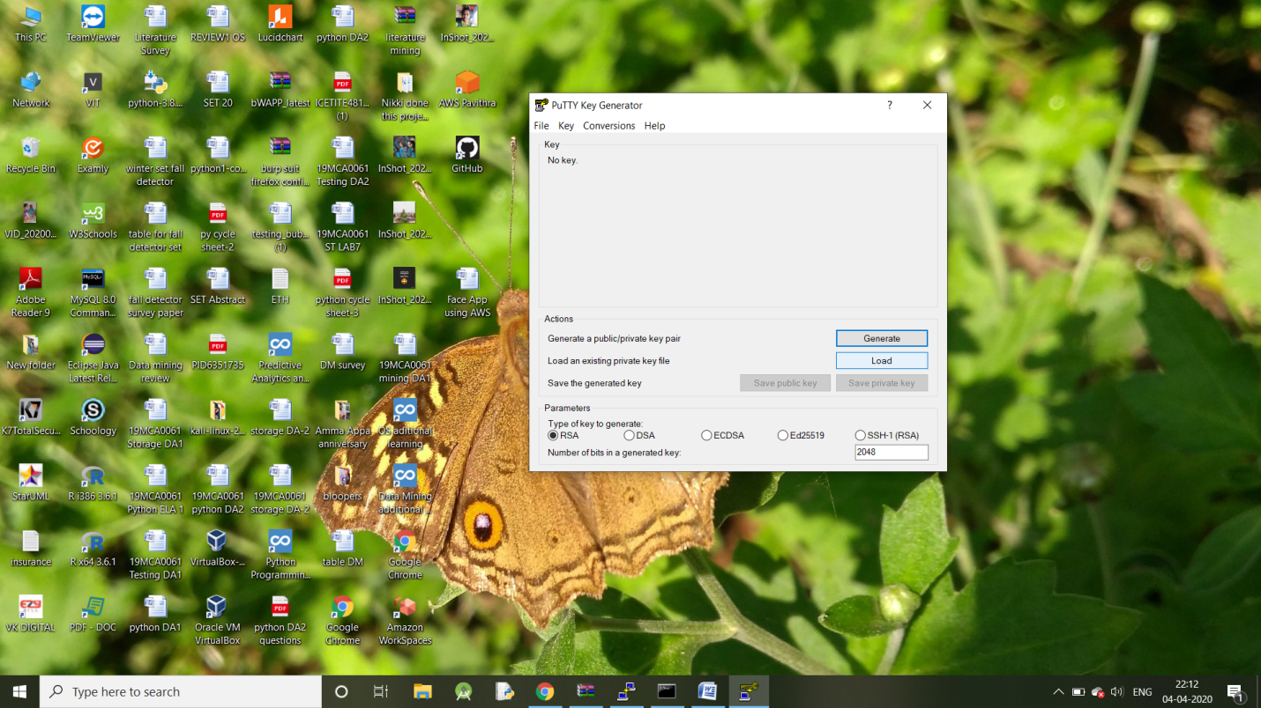

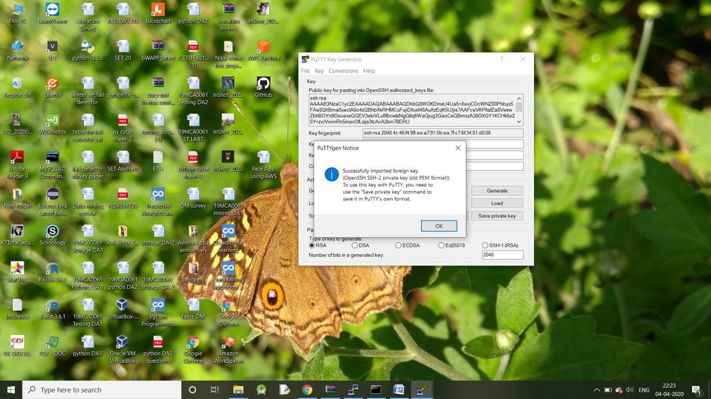

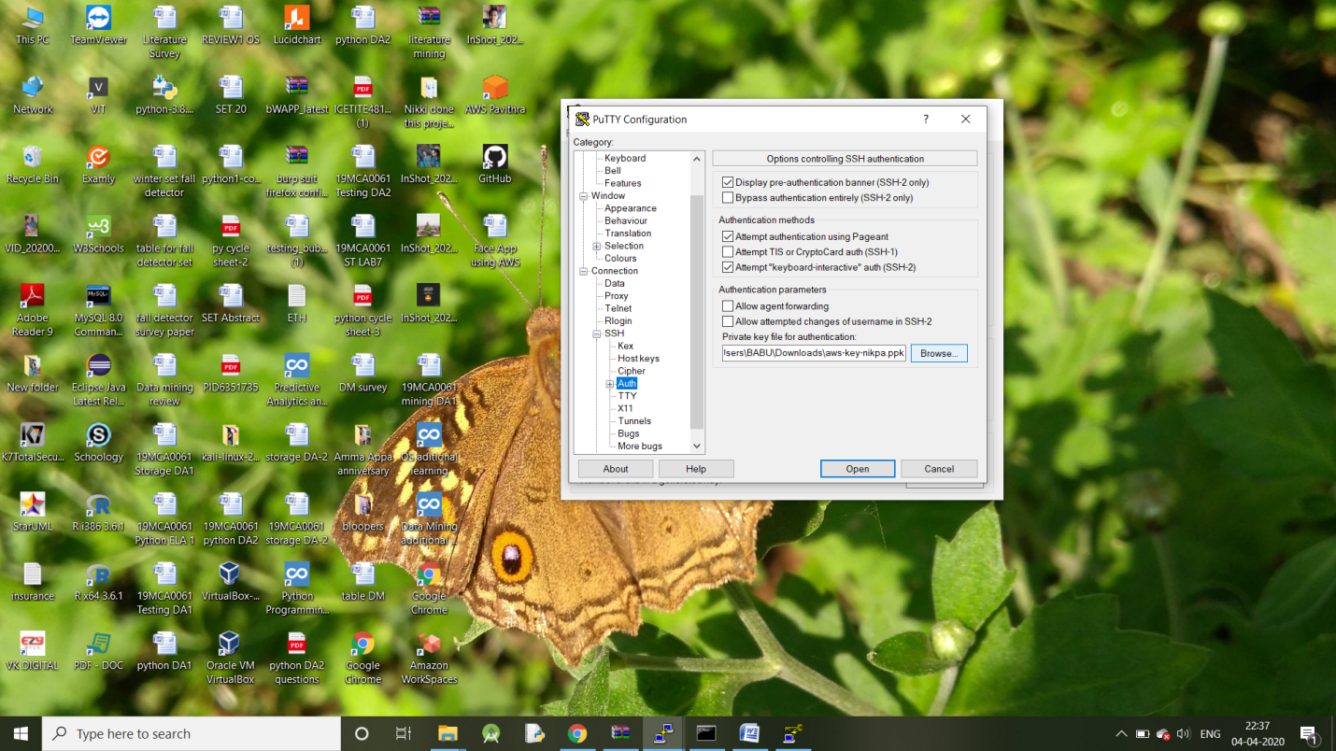

**Login to Putty:**

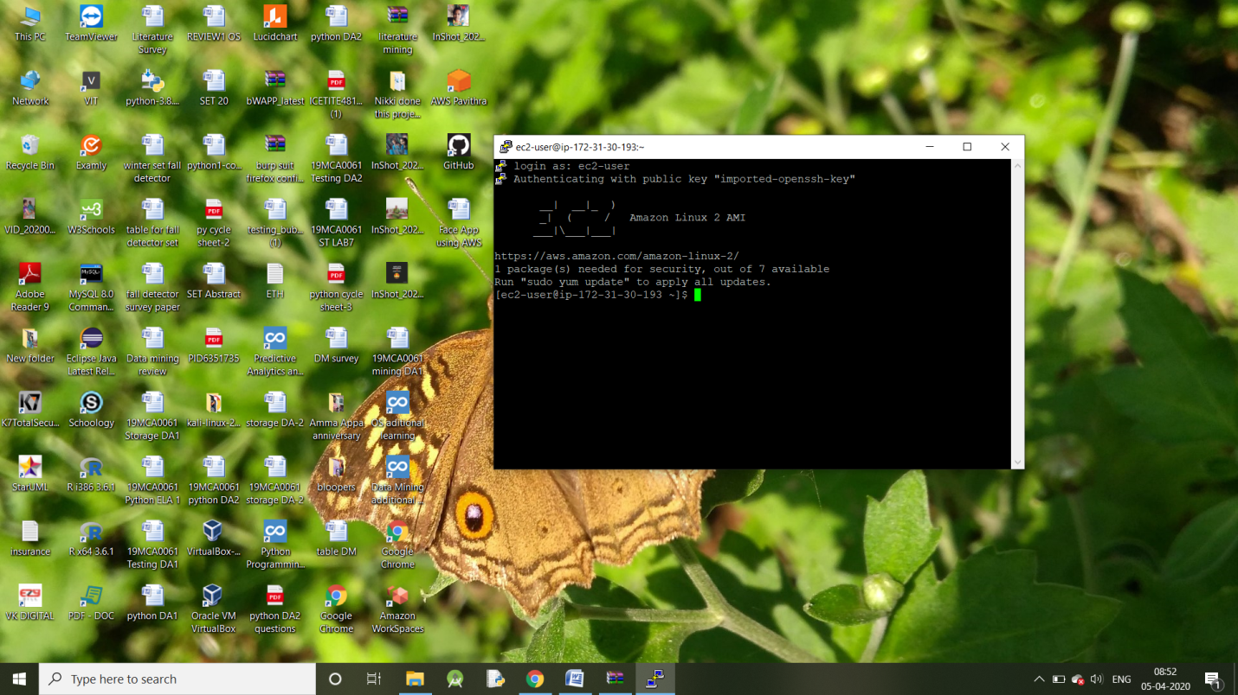

**DAY-2**

**A.Creating S3 Bucket:**

**BUCKET NAME:**

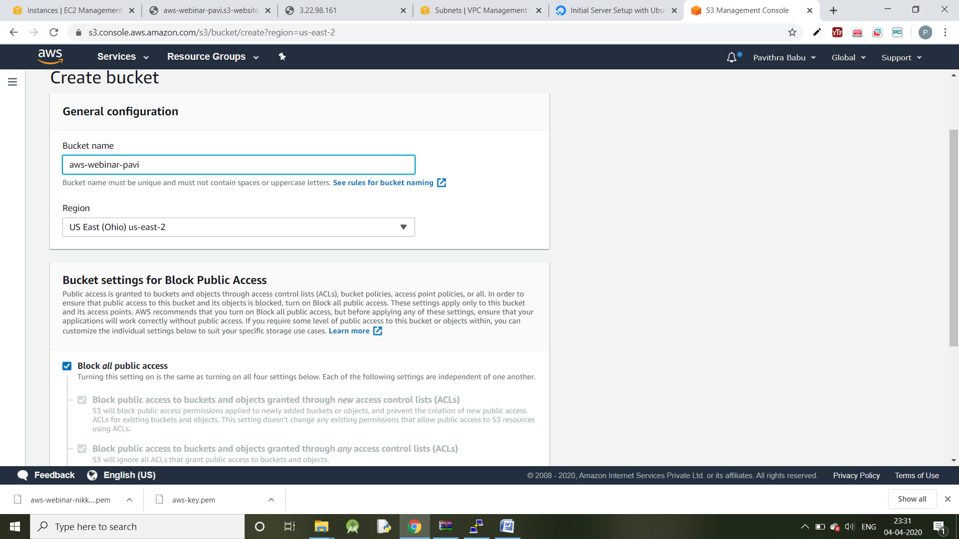

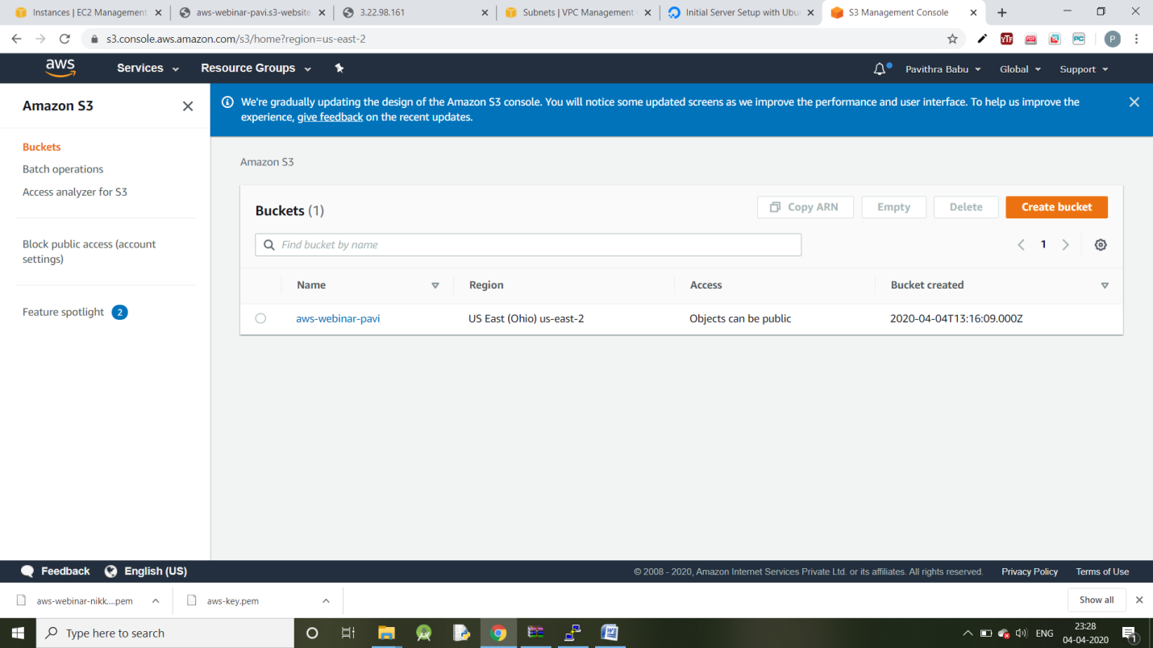

**B.Uploading an object:**

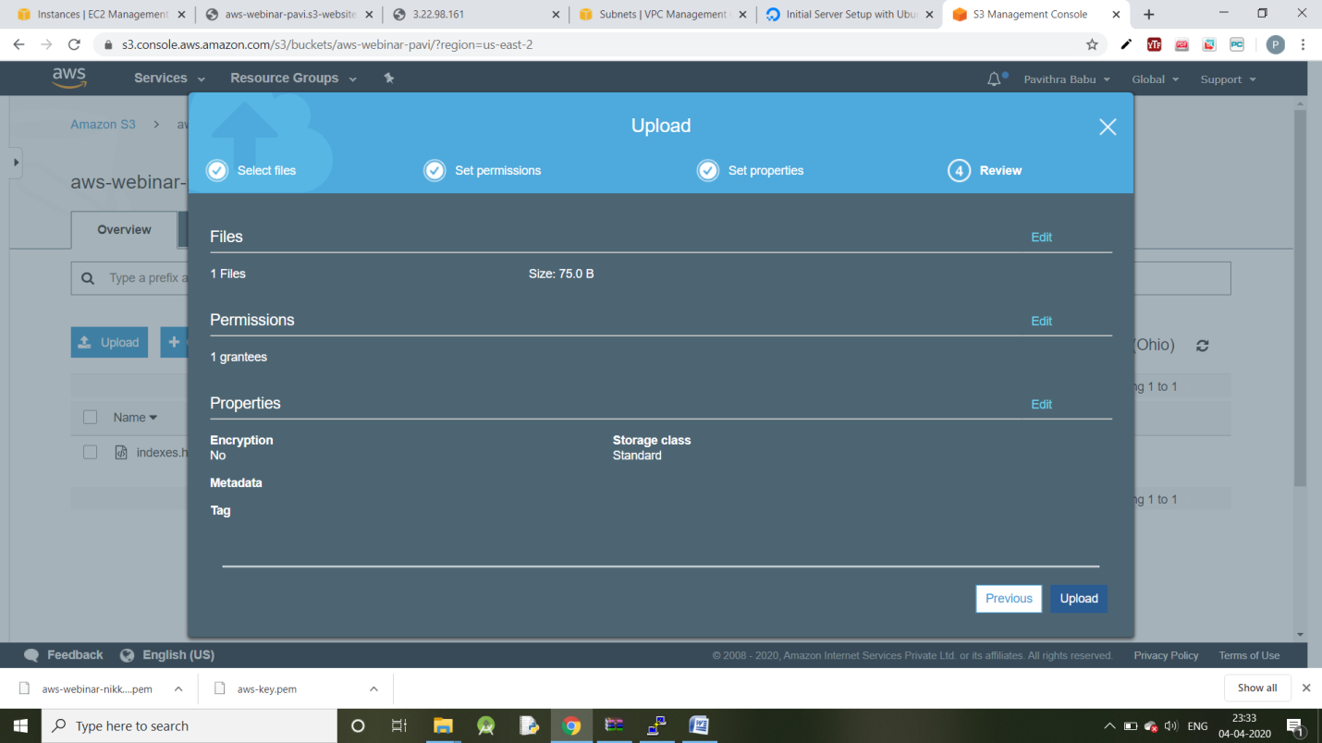

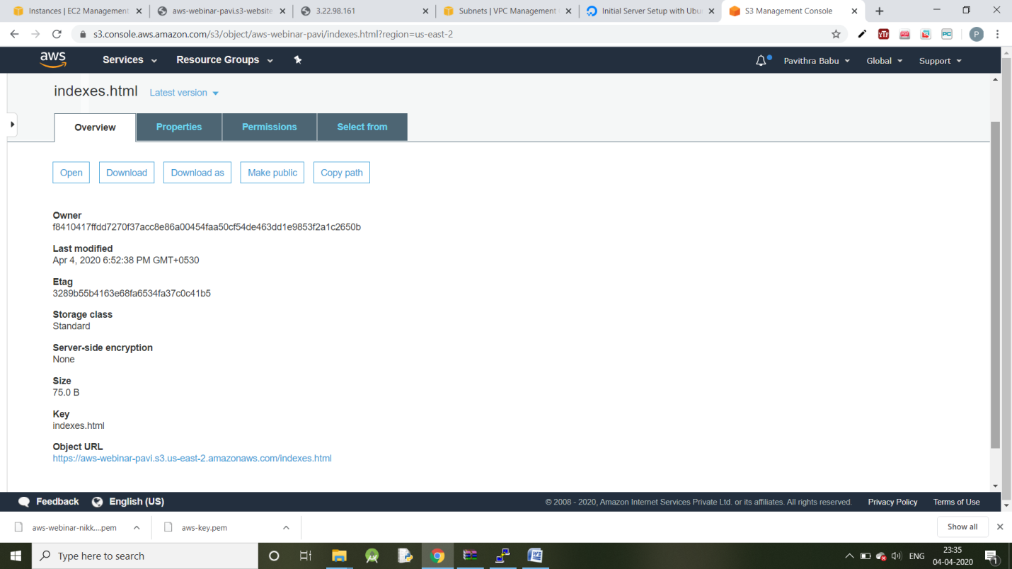

**C. Enabling static website hosting:**

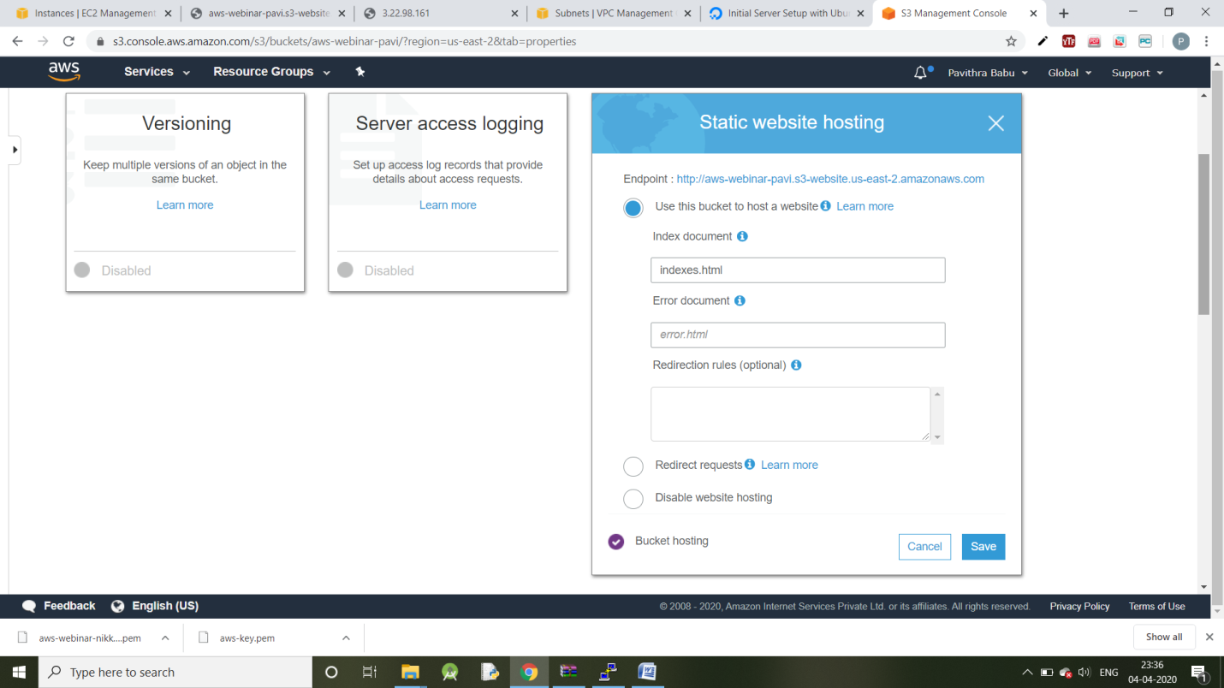

**D. Making the object as public:**

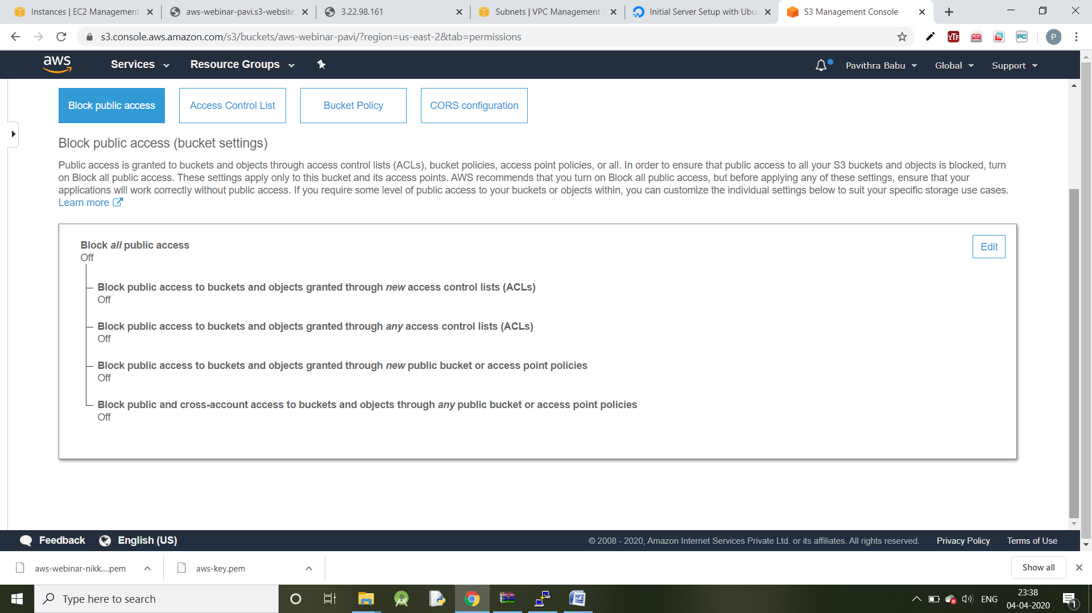

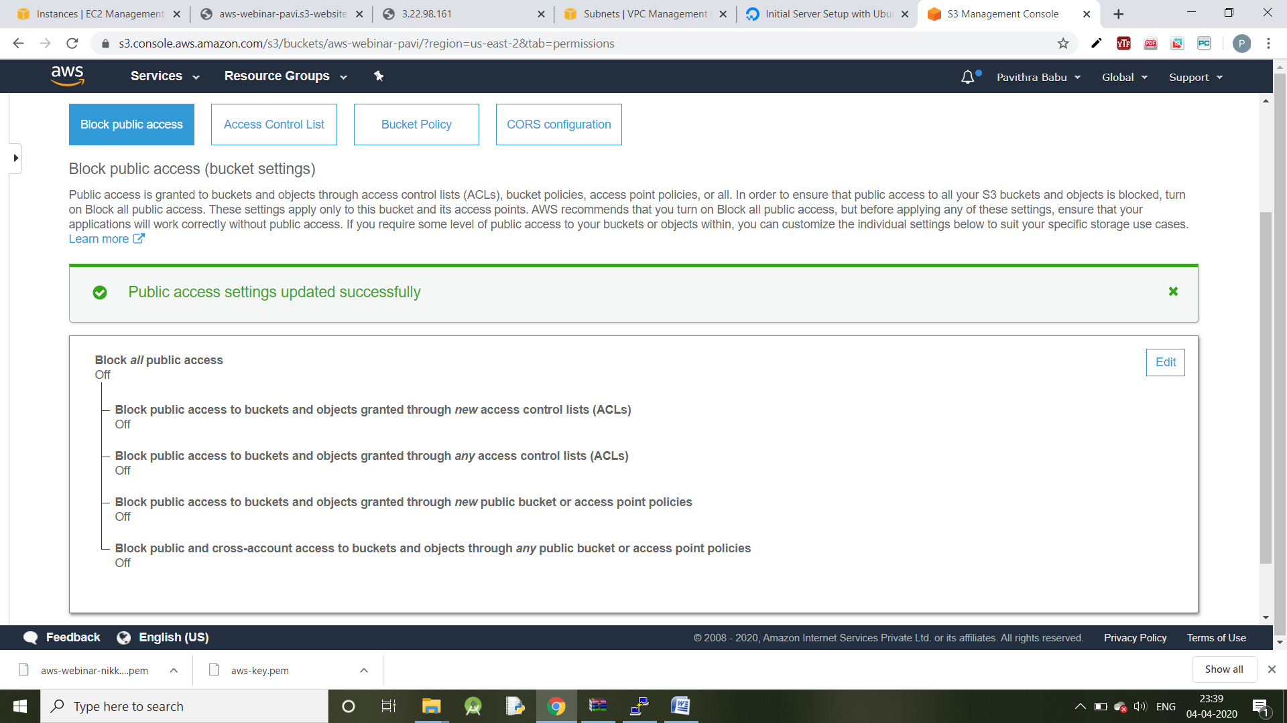

**E. Checking S3 link on the browser:**

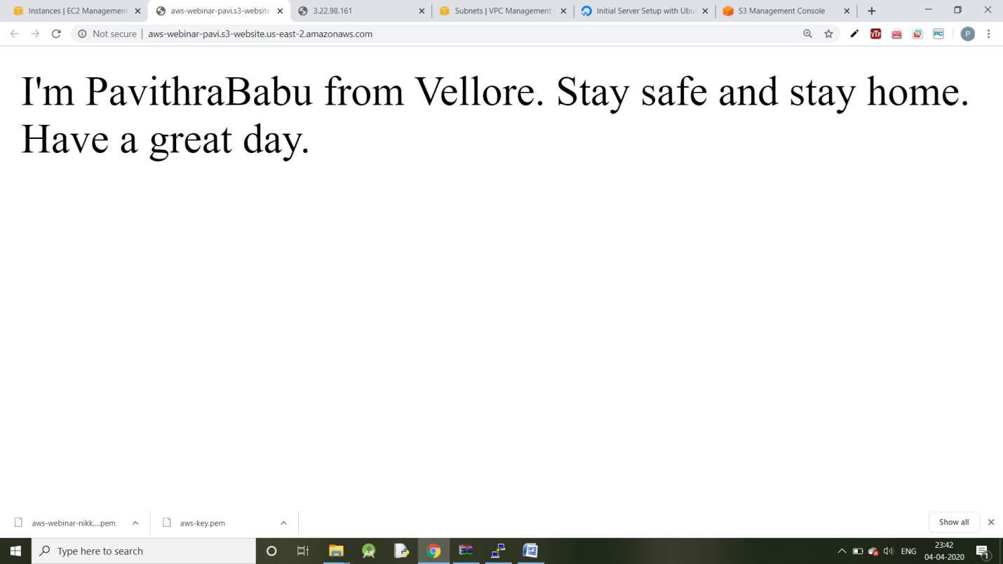

**DAY-3:**

**EC2 and S3**

**Installing AWS-SDK:**

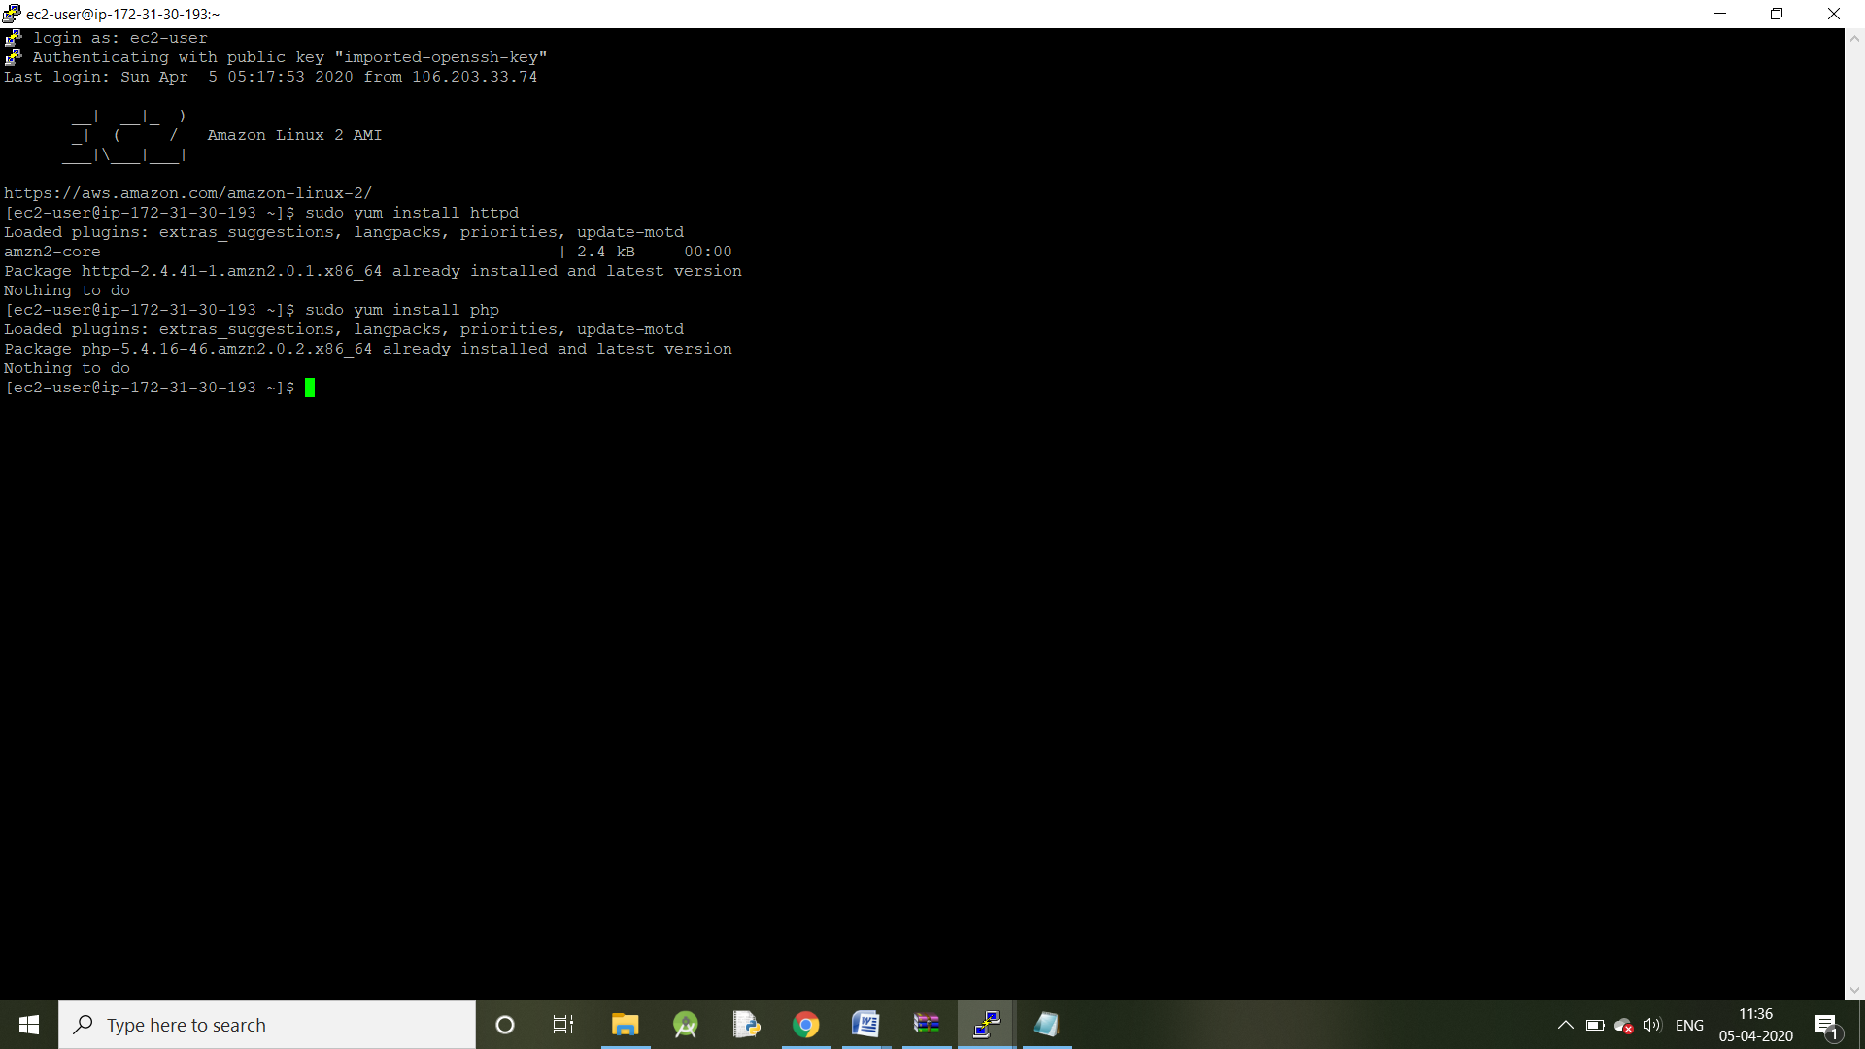

**IAM role:**

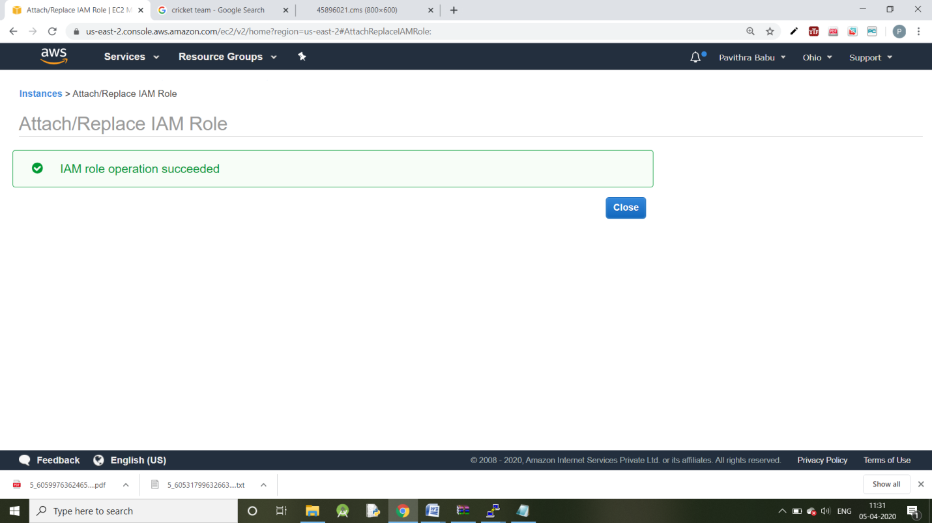

**Image upload done:**

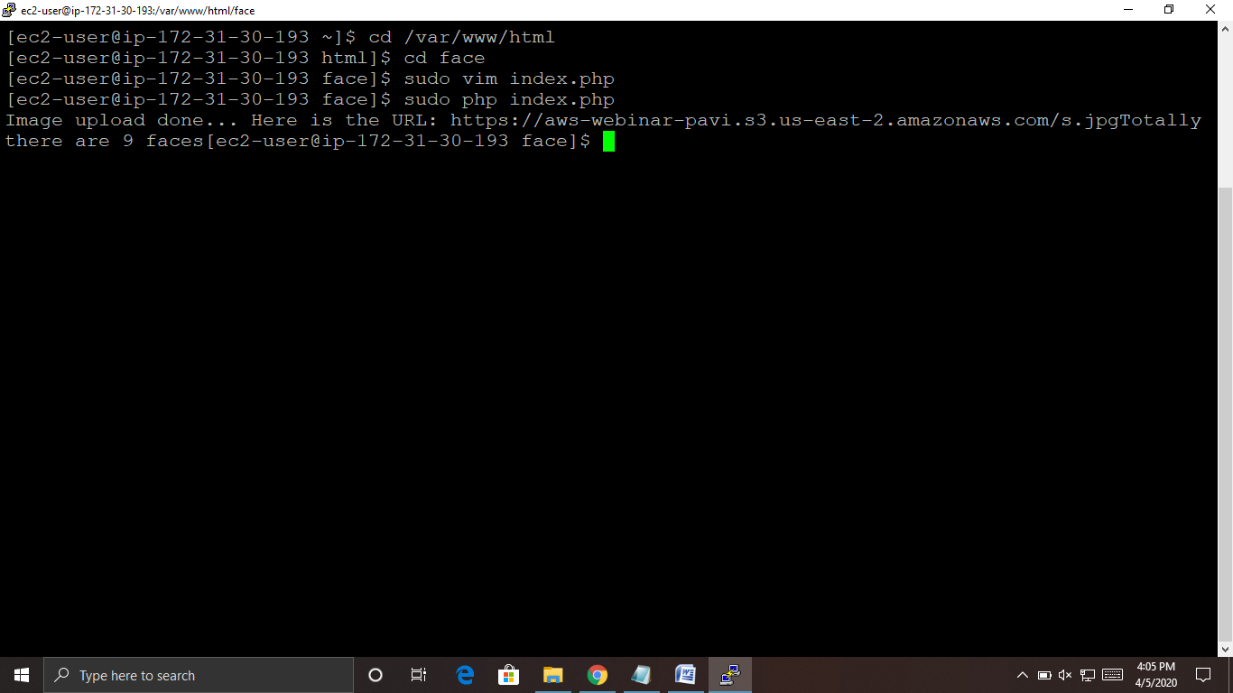

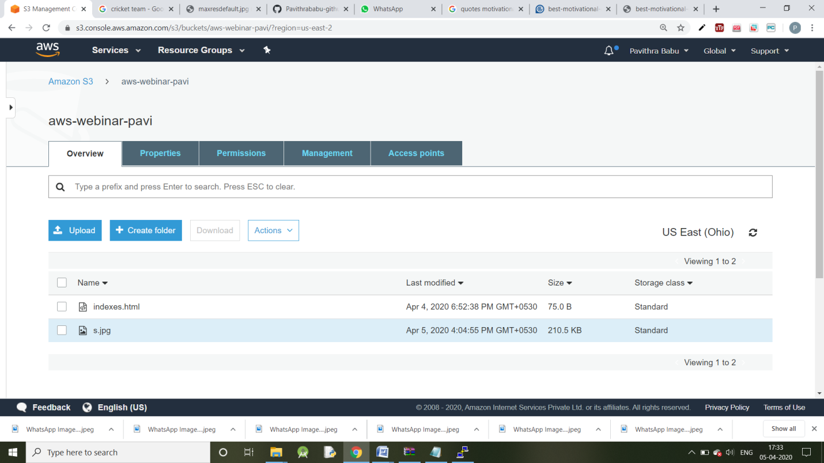

**Day-4:**

**EC2 and Rekognition:**



**AWS Rekognition:**

**Face Analysis:**

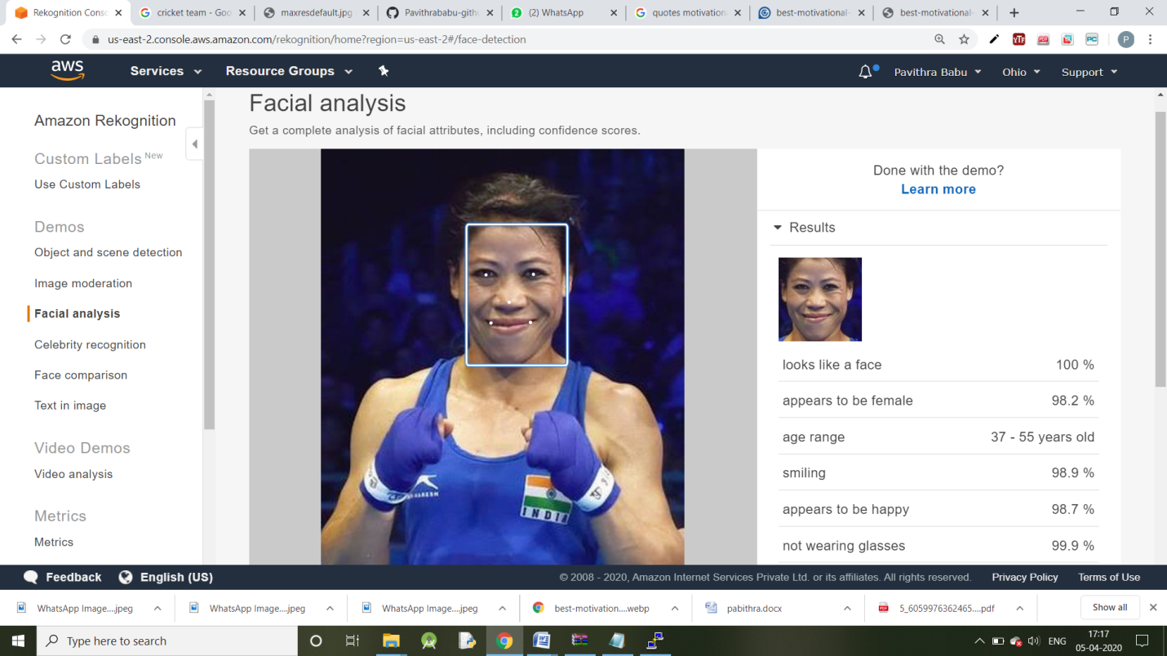

**Celebrity Recognition:**

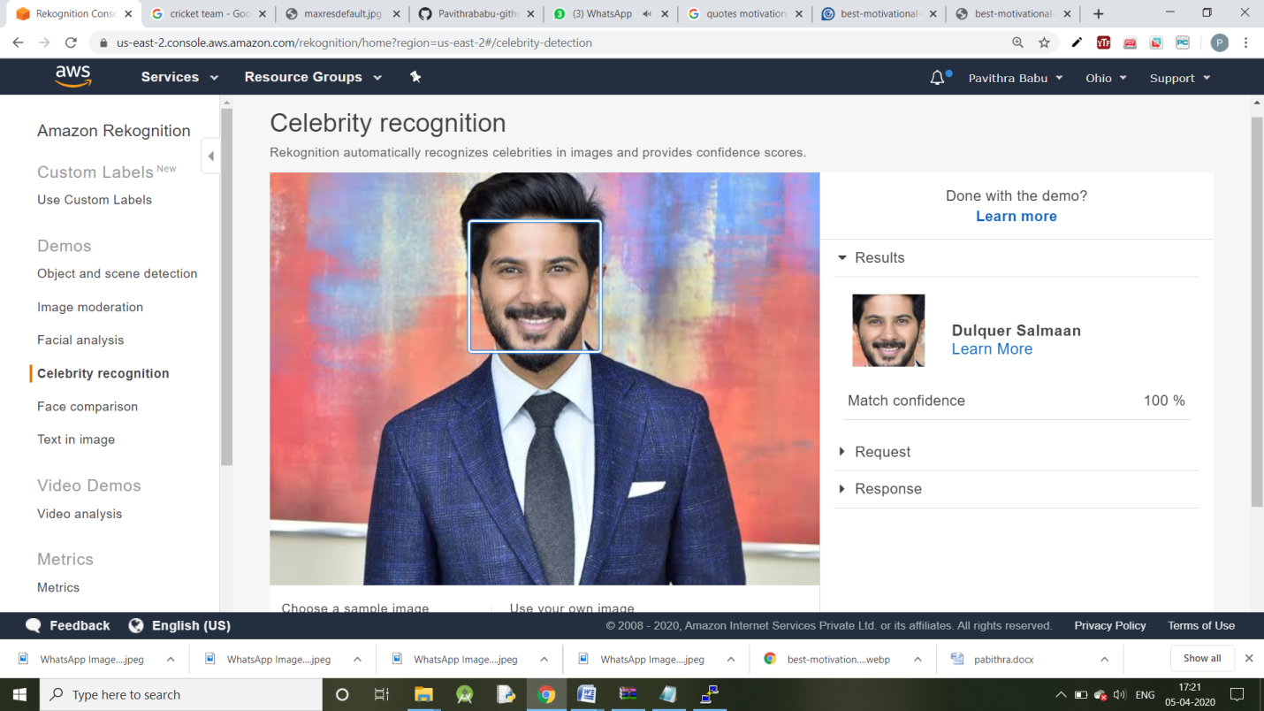

**Face Comparison:**

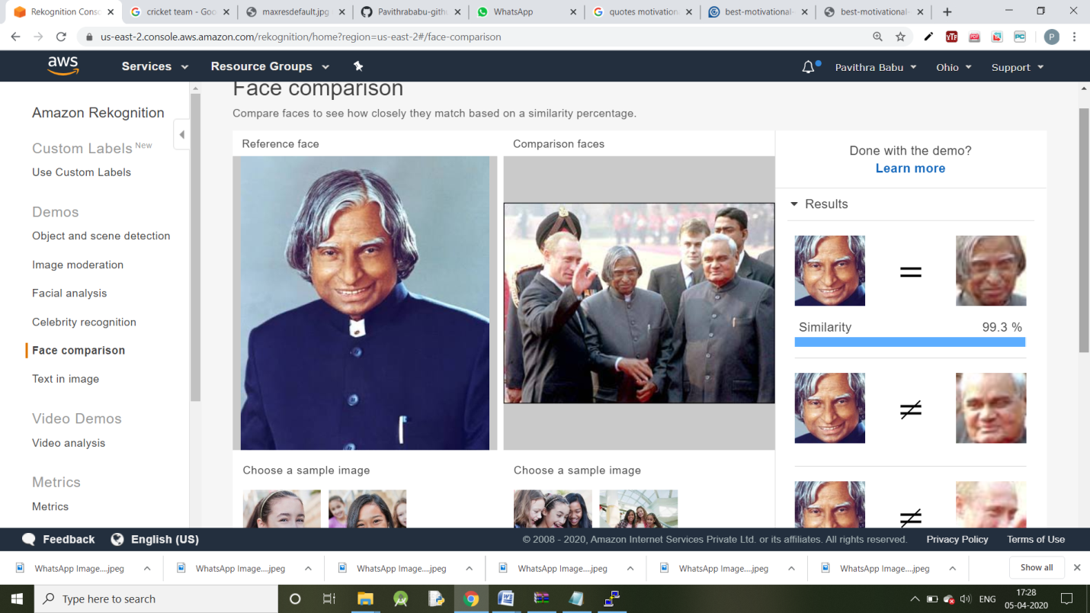

**Text in image:**

